SSY130, Applied Signal Processing

Project 1A
Acoustic Communication System

Group 8
Secret Key: Slaking
DOB: 19880803

Kashif Shabir
Haitham Babbili
Muhammad Haris Khan

Task 1
a)
The received signal before and after the equalization is same because there is no noise, no sync error and channel is perfect which theoretically means and that’s what the graphs shows. The error vector magnitude is equal to 3.03e-16 while BER= 0. The reason behind why BER is zero is the discretization from logical value to the digital value which under this case created no error that’s why we got zero BER. However, EVM still non-zero because matlab use approximation while using different steps like IDFT/DFT and equalization and when it converted back it shows some error which is depicted in term of EVM
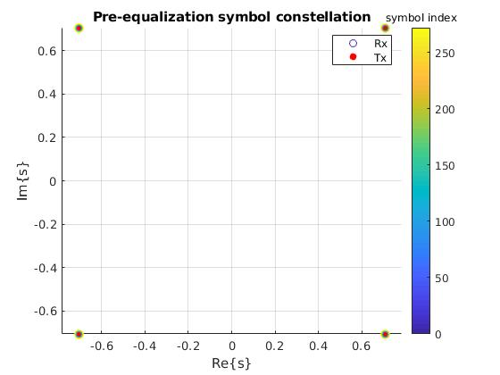
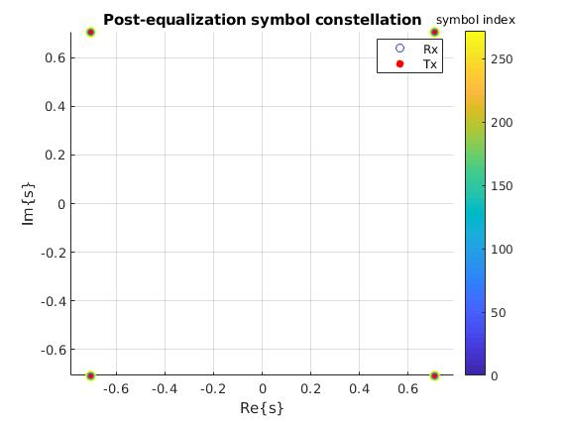

b)
The objective of cyclic prefix in to achieve periodicity such that the received symbol show same periodicity like the transmitted symbols such that we can implement our technique easily. In order to achieve near zero EVM , where M is the length of transmitted signal. But if is less then above value then there will be a mismatch is received and transmitted signals and we will get errors because no equalization recover them as they sampled at wrong frequencies.
c)
The points shrinked and rotated before equalization but became exactly the same after equalization. Mathematically speaking where ➔ and since is 0.5 which act as a shrinking factor which is also calculated from graphical perspective proves the same point along with the rotation rotated the signal by ½ radians. So, we have perfect channel at receiving end which is exactly equal to the transmitted that’s why in post equalization at points are at their exact place.
Alpha = 0.35355 /0.70711=0.5
EVM: 3.03e-16, BER: 0
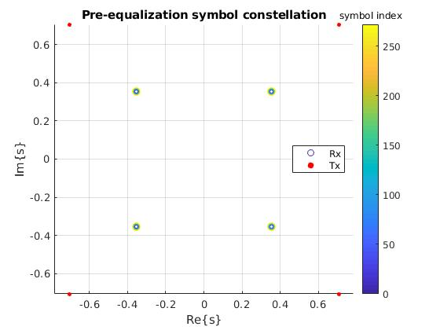
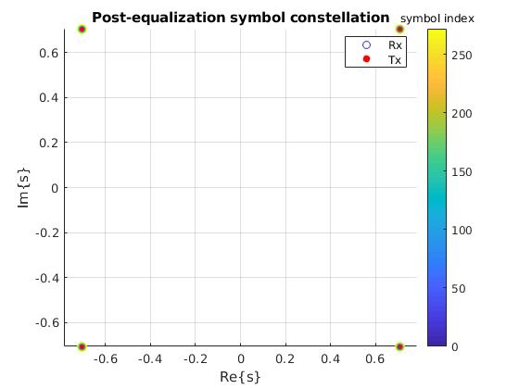
channel h3, the point are rotated anticlockwise before equalization but after equalization they rotate back to original position
Alpha = angel (y) – angle (z) =28 degrees
EVM: 3.6e-16, BER: 0
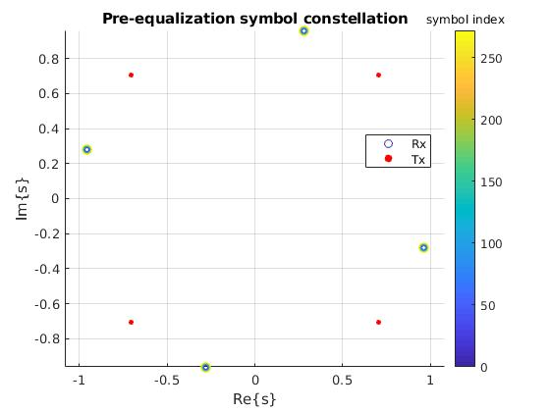
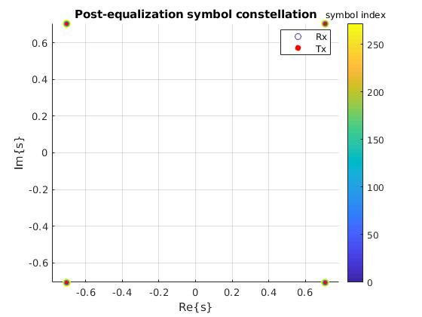

d)
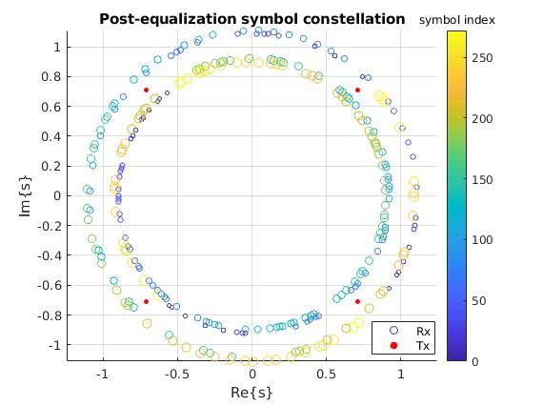
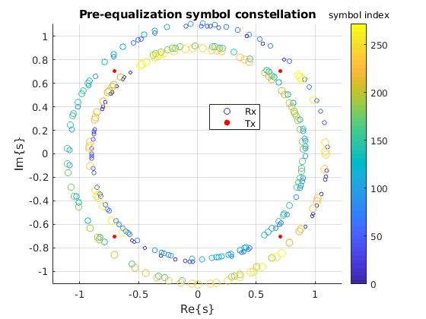

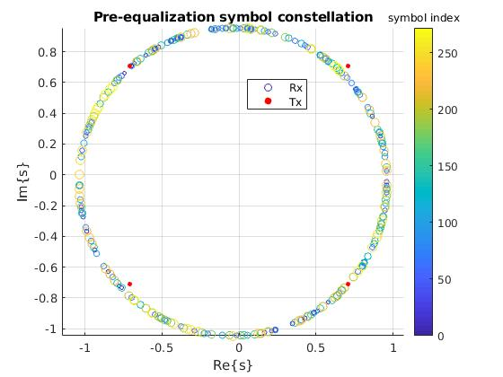
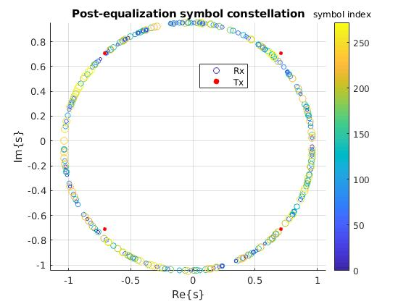

The delay in time means phase shift in frequency and due to this delay (which is actually caused by sync error or vice versa) the BER and EVM increases as compared to no sync error because of imperfect synchronization.

What we found is that the increase in synchronization error increases the frequency equal to length (sync error) which can be corresponded into the different number of message sections. A message is divided into number of sections (due to the length of sync error). And every time the start and end of each section remains unchanged because of the added cycling prefix. Concisely it means sync error correspond to the length of sections.

e)
When we start adding noise which is random the signal points will move in different directions randomly from the original transmitted points. This movement in different directions depends on the noise power which ultimately depends on the SNR and there is an inverse relation between SNR and this movement, which can be seen in the following figures.
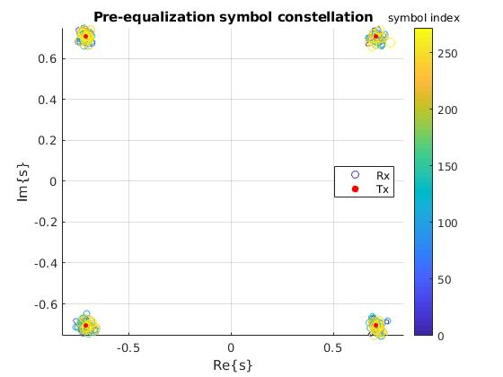
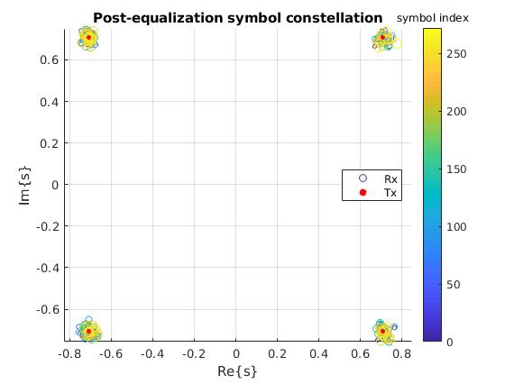

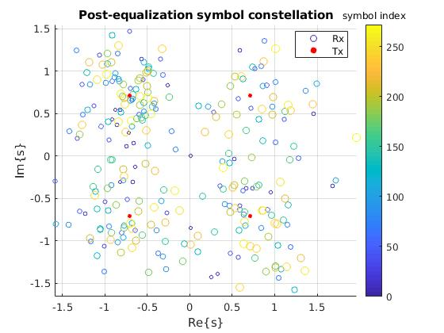
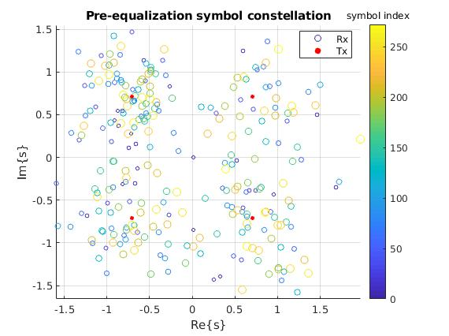

Task 2
a)
We find 3.5(-1+j)point at h(1)= 5 since this is the transmitted point. Broadly, magnitude and phase of the channel changes the constellation points’ magnitude and phase. If phase response decreases then constellation points start rotating clockwise what we observe in the 2nd half of the constellation before equalization. More sharp the increase or decrease the magnitude response corresponds to the less thickness of the constellation points. When magnitude changes slowly and phase increases linearly the constellation points become more thick towards clockwise direction.

b)

EVM: 1.06e-15 and it will be almost zero at and why EVM is zero after that point we already explained in task1.b. Whereas, BER is independent of .

c)
EVM: 4e-15, BER: 0.235
The post equalization diagram shows us that we accurately maps our transmitted symbols but BER telling us a different story that we are detecting 23.5 % wrongly even EVM is very low. This is due to the fact that we wrongly mapped our symbols because the channel is nonlinear.

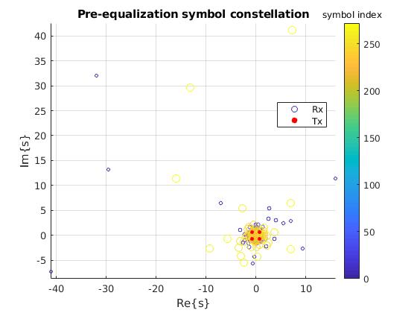
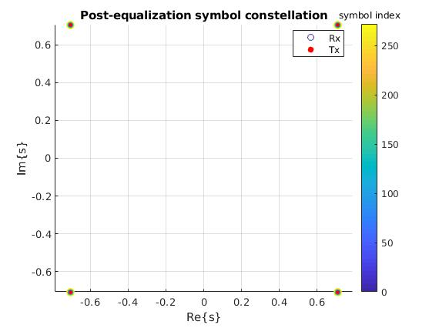
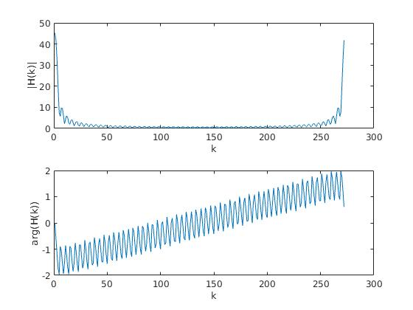

Task 3

a)

Transmitted: 'Alice: Would you tell me, please, which way I ought to go from here?'
Received: 'Mad Hatter: "Why is a raven like a writing-desk?""Have you guessed t'
EVM: 0.164, BER: 0.336.

We realize shift in symbol by /4 after synchronizing error with delay that cause phase shift in frequency domain in frequency element due to equation
.
While the unknown channel has deferent equation
Where transmitted pilot symbol and is received pilot symbol so will not affect by error in the synchronization if transmitted and received pilot symbol have no deferent in frequency element (same phase).

b)
EVM: 5.08e-15, for N, N/2 and N/4 EVM unchanged and less than e-15 for all these values which is similar as what we found for known channel.
For N_cp=N/4 and unknown channel
SNR=30: EVM: 0.492, BER: 0.342
SNR=10: EVM: 2.26, BER: 0.45
SNR=5: EVM: 2.7, BER: 0.474
SNR=0: EVM: 3.72, BER: 0.48

For N_cp=N/4 and known channel
SNR=30: EVM: 0.33, BER: 0.252
SNR=10: EVM: 3.3, BER: 0.43
SNR=5: EVM: 5.86, BER: 0.46
SNR=0: EVM: 10.4, BER: 0.463

At fixed N_cp=N/4 the EVM and SNR for unknown channel is higher as compared to the known channel because for the unknown channel we have to estimate channel who may not be estimated accurately which added some error that is why we are getting higher BER and EVM for unknown channels as compared to known channel.

c)
At N_cp=N/4, SNR= infinity, Unknown Channel, h5 and no synchronization error:
We got these values EVM: 0.289, BER: 0.336 even at high SNR. Since come to minimuize EVM so we set N_cp= 8 and M=8 and we get h5(0) = 0.5 and h5(8) = 0.5 because the channel is multi path and fading will affect the performance because we need to sum the results of both paths h5(n) = 0.5 *h1(n) + 0.5 * h1(n -8), so that is why BER is higher as compared to single path channel.

For h`5:
EVM: 6.17e-16, BER: 0.336
The BER remains same for h and h’ but EVM is changing.

NOTE: We perform lot of simulations for known and unknown channels considering single and multi-path channels and we found the above results. And because difference in these paths h`5 is not zero and BER at free noise equal to zero

d)
Table.1 Performance for different parameters
SNR | N_cp | Syn error | Unknown channel  single path multipath |  | BER/EVM
30 | N/4 | 1 | OK |  | 0.336/0.208
20 | N/4 | 0 |  | ok | 0.336/0.372
10 | 55 | 0 |  | ok | 0.371/1.08
0 | 30 | 1 |  | ok | 0.454/2.39

Looking carefully in the table the channel behavior is very different for different scenarios like for different channels types the BER and received message changes rapidly and this also happen for SNR, N_cp, and sync error. Therefore, overall, we can say our system is not robust but its sensitive and become more robust for negative value to synchronization errors.

